 | Hkkjrh; izksS|ksfxdh laLFkku xqokgkVh  Indian Institute of Technology Guwahati  Guwahati 781 039, India

Chairman, Cultural Affairs Board

 | Name | Period
 | Name | From | To
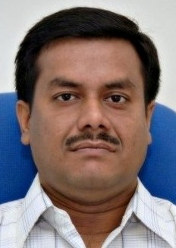 | Dr. Debasish Ghosh, ECE | - | -
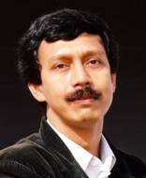 | Dr. Chandan Mahanta, CE | 18/9/2006 | 30/6/2008
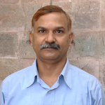 | Dr. J. K. Deka,  CSE | 19/8/2008 | 18/8/2010
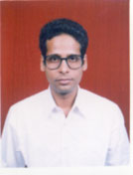 | Dr. Sujit Kumar Dash, CE | 19/08/2010 | 15/02/2012
 | Dr. Kaustubha Mohanty, Chemical Engineering | 16/02/2012 | Till Date

